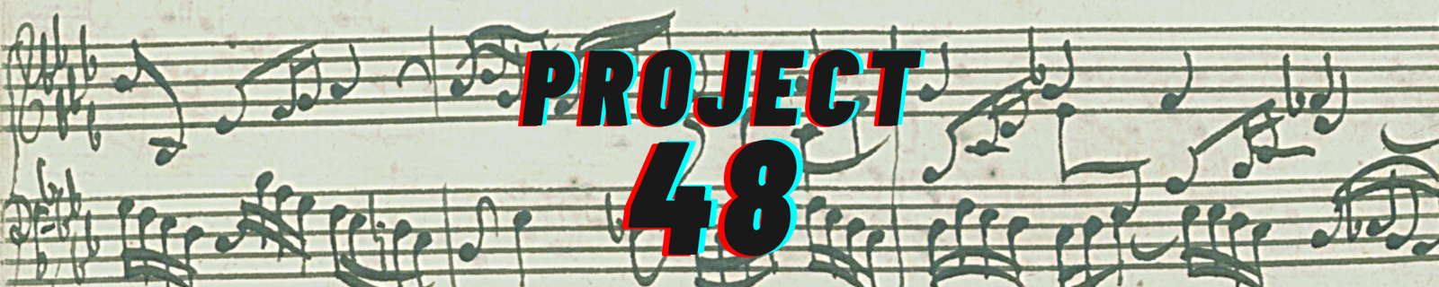

HELP MUSICIANS is an independent UK charity for professional musicians of all genres. In 2020, Help Musicians provided over 19,000 musicians with Financial Hardship Funding in the wake of the pandemic. They offer a range of creative development funding, supporting professional growth and training, and run a free mental health service for everyone working in the UK music industry – Music Minds Matter.

YOUTH MUSIC works to break down barriers so that all children and young people are able to have musical lives, working particularly with those in challenging circumstances. They give grants to other organisations – small charities, arts venues, music businesses, youth clubs, music education hubs, housing associations, nurseries and more – to run music-making projects for children and young people aged 0-25.

FUTURE TALENT operates two programmes supporting gifted young musicians from low-income backgrounds across the UK. They provide workshops, one-to-one mentoring sessions with experts, and performance opportunities, as well as financial support and guidance. The charity is creating a permanent presence in the North of England, enabling them to better reach and support young musicians in the North and beyond.

LIVE MUSIC NOW facilitates thousands of interactive music programmes every year in care homes, hospitals, special schools, and other community and healthcare settings. LMN selects young, professional musicians, trains them, and sends them out into the community to perform. LMN was dreamed up by legendary violinist Sir Yehudi Menuhin, who said, “Music, amongst all the great arts, is the language which penetrates most deeply into the human spirit, reaching people through every barrier, disability, language and circumstance. This is why it has been my dream to bring music back into the lives of those people whose lives are especially prone to stress and suffering… so that it might comfort, heal and bring delight.”

