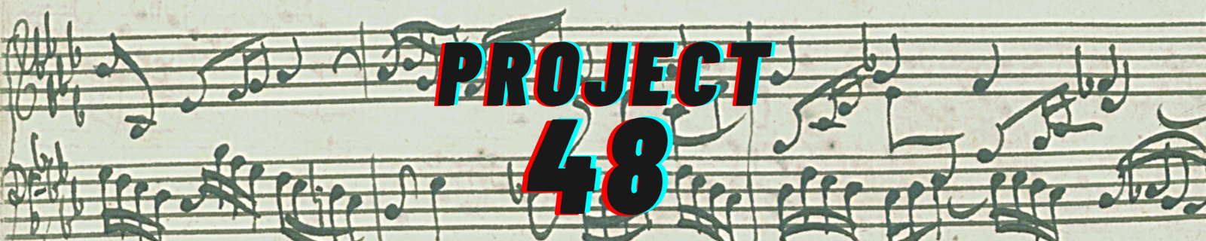

Das wohltemperierte Klavier (The Well-Tempered Clavier): ‘The 48’
Johann Sebastian Bach (1685-1750)

Book 1

Prelude & Fugue in C major BWV 846
Prelude & Fugue in C minor BWV 847
Prelude & Fugue in C sharp major BWV 848
Prelude & Fugue in C sharp minor BWV 849
Prelude & Fugue in D major BWV 850
Prelude & Fugue in D minor BWV 851
Prelude & Fugue in E flat major BWV 852
Prelude & Fugue in E flat / D sharp minor BWV 853
Prelude & Fugue in E major BWV 854
Prelude & Fugue in E minor BWV 855
Prelude & Fugue in F major BWV 856
Prelude & Fugue in F minor BWV 857
Prelude & Fugue in F sharp major BWV 858
Prelude & Fugue in F sharp minor BWV 859
Prelude & Fugue in G major BWV 860
Prelude & Fugue in G minor BWV 861
Prelude & Fugue in A flat major BWV 862
Prelude & Fugue in G sharp minor BWV 863
Prelude & Fugue in A major BWV 864
Prelude & Fugue in A minor BWV 865
Prelude & Fugue in B flat major BWV 866
Prelude & Fugue in B flat minor BWV 867
Prelude & Fugue in B major BWV 868
Prelude & Fugue in B minor BWV 869
Book 2

Prelude & Fugue in C major BWV 870
Prelude & Fugue in C minor BWV 871
Prelude & Fugue in C sharp major BWV 872
Prelude & Fugue in C sharp minor BWV 873
Prelude & Fugue in D major BWV 874
Prelude & Fugue in D minor BWV 875
Prelude & Fugue in E flat major BWV 876
Prelude & Fugue in D sharp minor BWV 877
Prelude & Fugue in E major BWV 878
Prelude & Fugue in E minor BWV 879
Prelude & Fugue in F major BWV 880
Prelude & Fugue in F minor BWV 881
Prelude & Fugue in F sharp major BWV 882
Prelude & Fugue in F sharp minor BWV 883
Prelude & Fugue in G major BWV 884
Prelude & Fugue in G minor BWV 885
Prelude & Fugue in A flat major BWV 886
Prelude & Fugue in G sharp minor BWV 887
Prelude & Fugue in A major BWV 888
Prelude & Fugue in A minor BWV 889
Prelude & Fugue in B flat major BWV 890
Prelude & Fugue in B flat minor BWV 891
Prelude & Fugue in B major BWV 892
Prelude & Fugue in B minor BWV 893
The Well-Tempered Clavier is widely considered to be a masterpiece of Western art, only rarely performed in its entirety. In 1722 Bach published a prelude and a fugue in each of the twelve major and twelve minor keys (Book 1), and twenty years later he repeated the process (Book 2). 12 + 12 + 12 + 12 = 48! Each of ‘The 48’ lasts only a few minutes, but between them they explore a wealth of characters, styles, and moods, representing not only the diversity of musical language available to the composer at the time, but also exploring the whole gamut of human emotional experience.

Pianist Libby Burgess is well-known on concert stages across Britain, playing in the country’s major halls and festivals, on Radio 3, and on a range of recordings. When not taking on crazy country-wide solo projects she collaborates as both song specialist and chamber musician with many of the UK’s finest instrumentalists and singers. Equally respected for her programming, she is founding Artistic Director of New Paths Music, and from 2018 to 2022 was Co-Artistic Director with Martin Roscoe of the Beverley Chamber Music Festival. Libby was formerly Head of Keyboard at Eton College, and is also in demand as coach, speaker and writer.
Beginning in 2021, Libby Burgess is performing Bach’s epic “48”, in every one of England’s 48 counties, raising funds for musical charities in the wake of the pandemic.

Bach wrote this magnificent collection “for the benefit and use of the musical youth eager to learn, as well as for the special pastime of those already skilful in this study.” This project is fundraising for musical charities who provide much-needed help to those same categories of people today – musicians young and old, learning and experienced. The nominated Project 48 charities are Help Musicians, Live Music Now, Future Talent and Youth Music. Between them they help hundreds of thousands of musicians every year, offering financial support, creating opportunities, addressing inequalities, and altogether safeguarding the future of the music world.

HELP MUSICIANS is an independent UK charity for professional musicians of all genres. In 2020, Help Musicians provided over 19,000 musicians with Financial Hardship Funding in the wake of the pandemic. They offer a range of creative development funding, supporting professional growth and training, and run a free mental health service for everyone working in the UK music industry – Music Minds Matter.

YOUTH MUSIC works to break down barriers so that all children and young people are able to have musical lives, working particularly with those in challenging circumstances. They give grants to other organisations – small charities, arts venues, music businesses, youth clubs, music education hubs, housing associations, nurseries and more – to run music-making projects for children and young people aged 0-25.

FUTURE TALENT operates two programmes supporting gifted young musicians from low-income backgrounds across the UK. They provide workshops, one-to-one mentoring sessions with experts, and performance opportunities, as well as financial support and guidance. The charity is creating a permanent presence in the North of England, enabling them to better reach and support young musicians in the North and beyond.

LIVE MUSIC NOW facilitates thousands of interactive music programmes every year in care homes, hospitals, special schools, and other community and healthcare settings. LMN selects young, professional musicians, trains them, and sends them out into the community to perform. LMN was dreamed up by legendary violinist Sir Yehudi Menuhin, who said, “Music, amongst all the great arts, is the language which penetrates most deeply into the human spirit, reaching people through every barrier, disability, language and circumstance. This is why it has been my dream to bring music back into the lives of those people whose lives are especially prone to stress and suffering… so that it might comfort, heal and bring delight.”

If you are able to, please consider donating to support these charities:
https://tinyurl.com/79e9c8df

You can also point your smartphone camera at this QR code to visit the donation site:

For more information on the project, visit www.bachproject48.co.uk, where you can read about performances around the country and sign up to the project mailing list.
You can also follow the project on Facebook, Twitter and Instagram: @bachproject48.

